New Computer Language Coding Concepts

Interface Connectors
Below you will find an overview of the possible connectors for the Interface aspect and the Interface Merged aspect.

Use As Interface | Use Reference As Interface
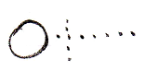 | 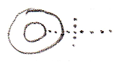
Interface Set
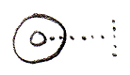
Object-Interface Get | Reference-Interface Get
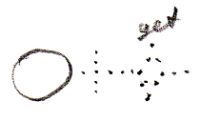 | 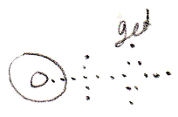
Interface Merged Get | Interface Merged Set
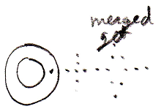 | 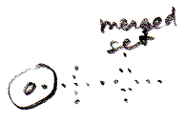

Author & Copyright: Jan-Joost van Zon Date: May 7, 2010 – May 7, 2010 Location: Oosterhout, The Netherlands Status: Finished

